**Batch Photograph Along With Guide**

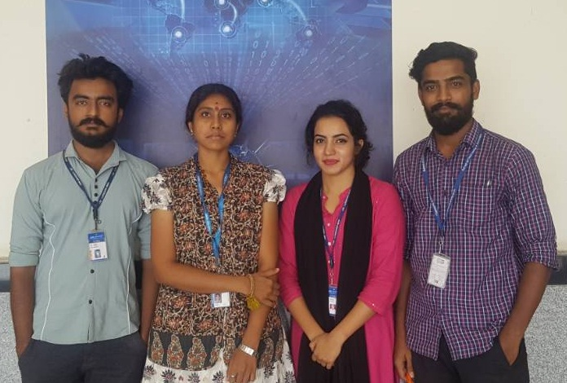

vii